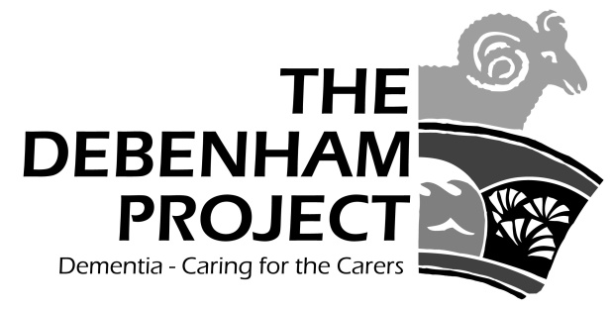

Hi everyone,

As you know The Debenham Project was set up to offer practical and emotional support for family carers, and those they care for, living in Debenham and the surrounding villages. We initially used what we called “the 4-mile rule” as a focus for our activities because, 4 to 5 miles is very roughly half-way between Debenham and its nearest neighbours e.g. Eye, Framlingham, Woodbridge, and Stowmarket. In an ideal world, community-based support such as ours would be freely available in these and every other Suffolk town so that families living with dementia would be able to find help “on their doorstep”. However, despite dementia care and support having been high on the public agenda it remains scarce and limited.

So the reality is that we just can’t set a distance beyond which we are not able to offer help. What would we say to someone living “just a bit” further away? Over the years we have welcomed families from Occold, Thorndon, Wickham Skeith, Grundisburgh, Earl Stonham, Ashfield, Otley, Stowupland, Kenton, Mickfield, Rishangles, Bedfield, Pettaugh, Framsden, and Wetheringsett to our Carers Club and Info Café, Lunch Clubs, Fit Club, and Cameo as well as offering support to a number of “remote” carers with loved ones in other parts of the UK. Of course, the Debenham community remains and always will be our primary focus.

Which brings me to how do we encourage local family carers of someone with dementia to make contact and benefit from our services and activities without unduly attracting more carers from beyond our boundaries than we have the resources to support. Over the years we have found that simply advertising with posters and articles in this and other village magazines is valuable but, by far the most successful way of persuading family carers to seek help lies in “word of mouth”. Until someone is really struggling to cope with the anxiety, stress and exhaustion that comes with dementia they may see a poster but not grasp its significance for them. However, talking about their problems with a friend who mentions “have you heard about …….” often leads to “I think I will give them a call ……”. So, Carol Garrett has initiated a programme to talk to as many of our local parish councils (and the GP practices) as we can to enlist their help in raising awareness of the impact of dementia and the work of the Project. And if we all are aware, then we may find ourselves saying to one of our friends or neighbours “have you heard about …….” The Debenham Project can take it from there.

To end, I always like to thank everyone who enables us to make a difference - volunteers, participants and donors. Especially, this month, a big thank you goes to the family and friends of Trevor Haste, and also those of Jack Haddow for the very generous donations made in their memory.

With all my best wishes,
Lynden Jackson
www.the-debenham-project.org.uk ; 01728 862003

