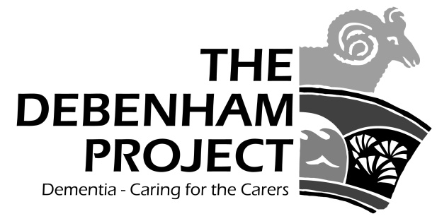

Hello everyone,
Getting There

At last we seem to have passed beyond the winter gales and chills and can look forward to spring sunshine and Eastertide. Over the past few months we have been busy recovering and rebuilding the project back to what it was way back in March 2020. So now our Carers Club and Info Café is now supporting between 20 and 25 twice each month and the number enjoying our weekly Fit Club seated exercise sessions is increasing slowly. Sadly we have not yet been able to re-open Cameo yet, and we lost 2 of our three monthly lunch clubs over the period of the pandemic. However plans are in hand to launch a new lunch club soon. Our transport for medically related appointments has been busy and we have also been helping a number of family carers navigate essential bureaucracy involved in such things as assessments, allowances, powers of attorney, finding professional carers, etc., etc. Things are going pretty much according to plan and that includes several events to look forward to this summer.

Deb-Fest on June 11th at the Leisure Centre

The Debenham Project Garden Party on June 25th at The Limes

A Day at the Seaside at Felixstowe on August 22nd

More of these closer to the time.

Finally, I would like to express my very grateful thanks to the family and friends of Hav Wilkins and Joyce Dennison for their very generous donations, all at Coopersfield for their kind donation, as well as all in our community for all the support that the Project continues to receive. Your support has ensured that we will be around for years to come. And don’t forget that we offer transport for anyone who has difficulty in getting to a medically related appointment, and also we have wheelchairs for short or medium term loan.

With all my best wishes for a very Happy Easter

Lynden Jackson

www.the-debenham-project.org.uk ; 01728 862003

